THEORY AND PRACTICE OF AEROSOL SCIENCE

F.R. ALEXANDER¹, J.O. NATHAN² and D.H. CHAPMAN²

¹Institute for Aerosol Research, Department of Chemistry, University of Bodmin,
Bodmin, Cornwall, PL77 6GT, United Kingdom.

²Department of Geophysics, University of Munster, Killarney, Kerry, Republic of Ireland.

Keywords: WWWWW, XXXXX, YYYYY, ZZZZZ.

INTRODUCTION

The abstracts produced should be camera-ready, and TWO pages long on separate sheets of paper. On the first page of the abstract, start typing text here (about 7cm from the top of the typing area). Text on the second page can start at the top of the typing area (where the title is on this page). All parts of the abstract should lie in a box 240 mm high and 165 mm wide. There should be a top margin of 29 mm depth and a left margin 23 mm wide. Times New Roman font is preferred, and you should use a character size of 11pt. The title should be in bold capitals, the authors’ names should be in capitals, and the addresses of authors should be in lower case. All these should be centred.

METHODS

You can include up to four keywords or keyphrases, as shown. Pages should not be numbered. You may arrange your text under headings, in capitals and centred. Figures and Tables may be included in the abstracts, but please make sure that they all have a caption, and that they are numbered consecutively using Arabic numerals. The font used in captions can be smaller than used elsewhere, but be advised that anything smaller than 10pt may become illegible when reduced (slightly) for printing. Make sure that the caption fully describes all the features in the Figure or Table. Vertical lines in tables should be avoided.

Month | Measured density (g/cm3) | Predicted density (g/cm3)
January | 0.4 | 121
February | 0.7 | 379
March | 0.9 | 845
May | 1.3 | 1030
June | 2.4 | 15280

Table 1. Comparison between theoretical predictions and experimental measurements.

References should be made in the style (Chapman, 1975), or (Alexander and Nathan, 1986; Finn et al., 1998) or simply refer to Finn et al. (1998). Examples of journal articles, Conference Proceedings and book references are shown overleaf.

CONCLUSIONS

The authors are invited to submit a two-page abstract on any topic related to aerosol science. The authors are also asked to facilitate the abstract 1review process by classifying their contribution according to one of the following topics: Health aspects of aerosols, Fundamental aerosol physics, Electrical Effects, Intrumentation, Nanoparticles, High Temperature Aerosols, Atmospheric Aerosols, PM-10/2.5, Indoor aerosols, Radioactive aerosols, Bioaerosols, Industrial aerosols, Aerosol Chemistry or Modelling.

The abstracts will be reviewed by the symposium organizers according to scientific content, suitability for the symposium and form. Abstracts which do not fulfil the standards will be rejected. Please, avoid to submit one-page abstracts or abstracts containing only future results.

Please submit your abstract in camera-ready form according to the guidelines given here.

The authors are welcome to submit abstracts in PDF-format plus the abstract classification form in Word directly via online upload or in case of problems via email attachment to nosa2007@dmu.dk.

The deadline for the abstract submission is September 24, 2007.
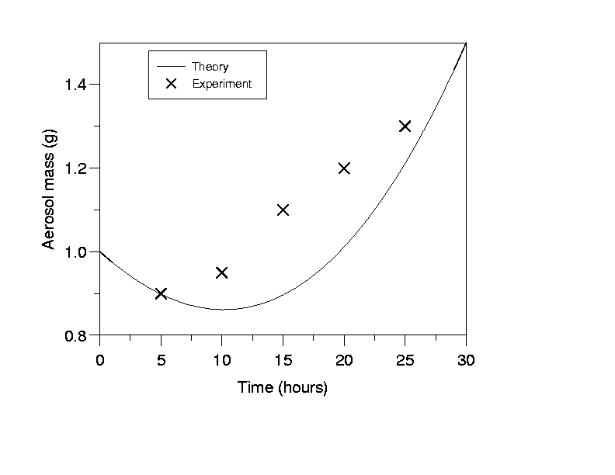
Figure 1. This is the sort of Figure which illustrates good agreement between theory and experiment.

ACKNOWLEDGEMENTS

This work was supported by the National Council for Aerosol Research under grant A1/001.

REFERENCES

Alexander, F.R. and J.O. Nathan (1986). An Introduction to Ultrasonic Nebulisation, (Cambridge University Press, Cambridge, U.K.).
Chapman, D.H. (1975). Optical scattering from combustion aerosols, J. Aerosol Science 36, 3456.
Finn, P., G.N. Diver and K.T. Wake (1998). Aerosol measurements in Iceland, in Proc. 13th Int. Conf. on Marine Aerosols, Reykjavik (Wiley, New York), 631.

